**Project Design Phase-I**

**Proposed Solution Template**

| Date | 15th November 2023 |
| --- | --- |
| Team ID | Team-591827 |
| Project Name | Unveiling Sentiments in Political Speeches |
| Maximum Marks | 4 Marks |

**Solution Architecture:**

Solution architecture is a complex process – with many sub-processes – that bridges

the gap between business problems and technology solutions. Its goals are to:

• Find the best tech solution to solve existing business problems.

• Describe the structure, characteristics, behaviour, and other aspects of the

software to project stakeholders.

• Define features, development phases, and solution requirements.

• Provide specifications according to which the solution is defined, managed,

and delivered.

**Solution Architecture Diagram:**

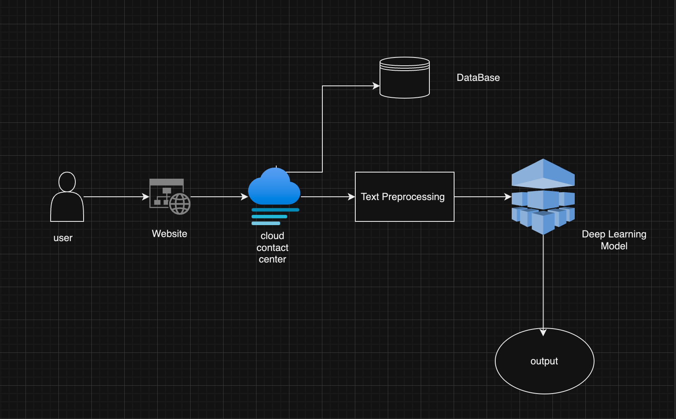

**Reference:**

[**https://drive.google.com/file/d/12FPTod-qopGCjdT-SrDm6IBHLMGKlmHc/view?usp=sharing**](https://drive.google.com/file/d/12FPTod-qopGCjdT-SrDm6IBHLMGKlmHc/view?usp=sharing)